***Monkey Goes Bananas: Lab Escape***

***“Eat bananas, go *pew pew*, gain your freedom!”***



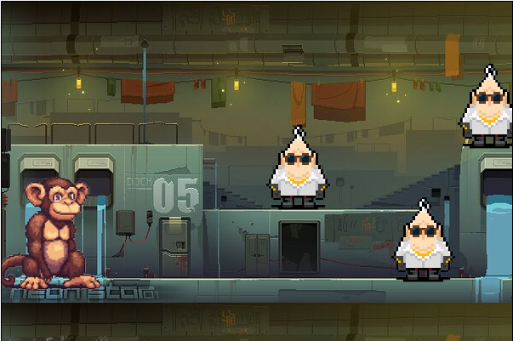

# ***Executive Summary***

Basic setting (1sentence)

The game is set in a high-tech science laboratory.

What makes the game interesting? (1sentence)

It’s fast-paced, action-packed and

Some selling point to convince the publisher to fund the game development. (1sentence)

Our game is new and never seen before, super Mario mixed with Asteroids.

# ***Overview***

Drawing inspiration from games such as Asteroids (1979) and Super Mario Bros. (1985), this arcade-style single-player shooter game has players take on the role of a monkey who was being experimented on by humans in a lab. We decided to use the film Rise of the Planet of the Apes (2011) as inspiration for the story of our video game. The goal of the game is to fight through the map by shooting and eliminating evil lab employees in order to reach the end of the map where the player will face the final boss: the despicable head scientist. Additionally, as the game progresses, players will encounter boxes which may be destroyed to reveal one of two possible power-ups. The first and more common type of power-up is a banana. This power up will temporarily increase the player’s strength by decreasing their damage intake; this power up will be visualized by increasing the player’s size. The second power-up will be a bit rarer to encounter. This power-up will be represented as a lab vial filled with a vibrant green fluid. If the player uses it, they will temporarily have an increased firing rate. Lastly, if the player manages to eliminate the final boss, they have won the game and have gained their freedom as a free monkey in the wild! Players will then see a winning screen with an image of a jungle background. However, if at any point during the playthrough they get caught, a losing screen with an image of a monkey (the player) behind bars will be displayed.